**Building Air Tightness Test Report of**

**Property Name**

**Prepared for:**

**Client Name**

**Client Address**

**Prepared by:**

**Test Company Name**

**Test Company Address**

**April 1, 2016**



Executive Summary 3

Next Steps 3

Building Air Tightness Test Overview 3

Building Overview 3

Building Description 3

HVAC Systems 3

General Building Condition 3

Building Plans & Take-offs 3

Testing Information 3

Weather Conditions 3

Equipment Specifications 3

Blower Door Configuration 3

Test Enclosure Boundaries 3

General Test Notes 3

Test Results 3

Observations & Recommendations 3

Appendix A – EarthCraft Light Commercial Test Information 3

Appendix B – U.S. ACE 3

Appendix C – Zone Air Leakage Checklist 3

### Acknowledgements

The following persons are thanked for their assistance in development of this report: John Doe.

### About Test Company

Insert company description.

# Executive Summary

Test Company performed a blower door test for Client Name at the Property Name located at Property Address, on BD Test Date. The test followed U.S. Army Core of Engineers Air Leakage Test Protocol for Building Envelopes and XXXX additional testing protocols. The objective of the test is to evaluate the tightness of the building envelope and identify opportunities for reducing infiltration thus cutting utility costs. Test findings are summarized below:

#### Envelop Leakage Ratio

Laksjdlasjd

#### 

Figure 1: Depressurization and Pressurization Fan Curve

#### Envelope Leakage Locations

The following leakage locations were observed during the test:

## Next Steps

Test Company recommends the following...

# Building Air Tightness Test Overview

The following report documents the results a blower door test for Client Name.

|  |  |
| --- | --- |
| **Organization Name** | Client Name |
| **Address** | Client Address |
| **Organization Contact** | Client Name and Phone # |
| **Test Date** | BD Test Date |
| **Property Name** | Property Name |
| **Property Address** | Property Address |
| **Southface Contact** |  |
| **Lead Tester** |  |
| **Support Testers** |  |
| **Testing Protocol Used** | U.S. Army Corps of Engineers Air Leakage Test Protocol for Building Envelopes plus XXX |

Table 1: Blower Door Test Overview

The test followed U.S. Army Core of Engineers (ACE) Air Leakage Test Protocol for Building Envelopes and XXX additional testing protocols. The objective of the test is to evaluate the tightness of the building envelope and identify opportunities for reducing infiltration thus cutting utility costs.

The report begins with a brief description of the facility, including the HVAC systems. It then reviews the testing process and test results. Recommended building envelope improvements are then presented as well as additional issues that are not included in the testing but warrant further attention. The U.S. ACE report from The Energy Conservatory’s TECLOG software and detailed notes related to the test procedure may be found in the Appendices.

# Building Overview

Property Name is a recreational facility for children and young adults. The Conditioned Floor Area square foot property was built in Year Built. The three-story building is comprised of classrooms, a computer lab, offices, bathrooms, game room, gym and several storage rooms.

|  |  |
| --- | --- |
| **Property Name** | Property Name |
| **Property Address** | Property Address |
| **Year Built** | Year Built |
| **Floor Area (Sq-Ft)** | Conditioned Floor Area |
| **Building Volume (Cu-Ft)** | Building Volume |
| **Elevation Above Sea Level** |  |

Table 2: Building Overview

## Building Description

Stand-alone, construction-type, building envelope – walls, floor, roof, notable features (e.g. porte-cochere)

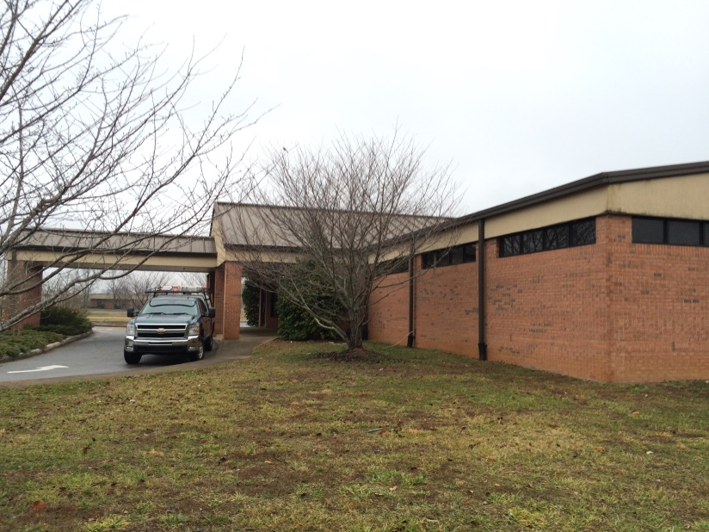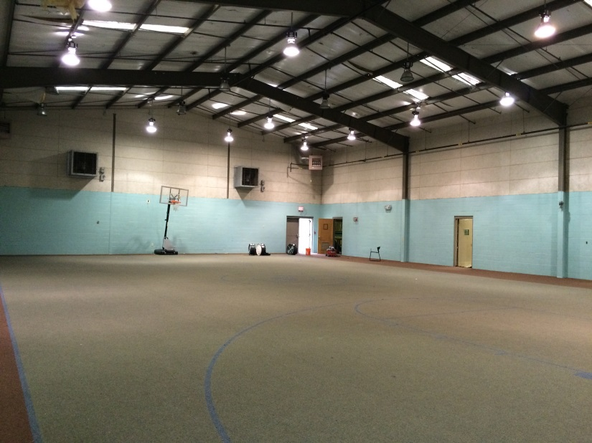

Picture 1: lakjsdalksd (left); ladkjsaisdj (right)

## HVAC Systems

Types and locations, outdoor air, make-up air, exhaust air (bath and kitchen), flues, and other envelope penetration descriptions.

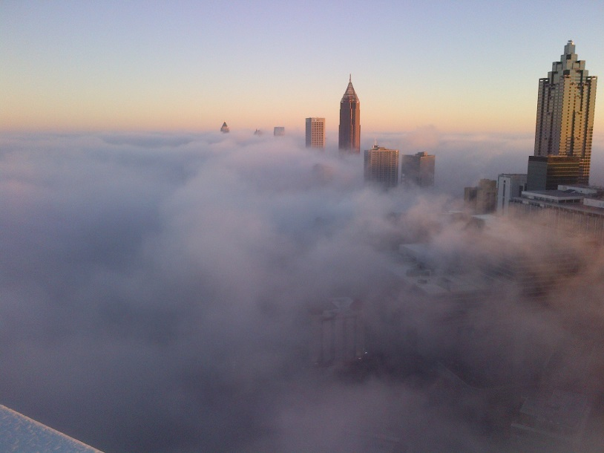

Picture 2: lqijweqiwje

## General Building Condition

If appropriate, describe general condition of building from a maintenance/up keep stand point.

## Building Plans & Take-offs

Describe how the take offs were completed

|  |  |
| --- | --- |
| **Floor Area (Sq-Ft)** | Conditioned Floor Area |
| **Building Volume (Cu-Ft)** | Building Volume |
| **Building Envelope Floor Area** |  |
| **Building Envelope Wall Area** |  |
| **Building Envelope Ceiling/Roof Area** |  |
| **Square Footage of Building Envelope (SFBE) 6-sided** |  |
| **Square Footage of Building Envelope (SFBE) 5-sided** |  |

Table 3: Building Dimensions

Insert building plan images and label appropriately using References>Insert Caption>Label: Picture.

# Testing Information

Test Company Name conducted single, and multi-point with regression analysis, blower door tests to determine the air tightness of the building envelope under normal operating conditions.

## Weather Conditions

Describe test weather. Starting and ending temperatures may be found in the U.S. ACE report in Appendix A. The starting and ending temperatures were recorded using ABC thermometer by NAME.

## Equipment Specifications

Test Company Name used blower doors, XXX gauges and related accessories from Equipment Company Name. A theatrical fog machine outfitted with site-installed ducting to allow for concentrated placement was used for visualizing leakage pathways.

The XXX gauges were confirmed to be within calibration dates and serial numbers were recorded. Specific factory calibration dates and serial numbers may be found in the U.S. ACE report in Appendix A. Additional field calibration is confirmed every other year following Equipment Company Name specifications for field calibration. Describe test-day calibration check.

## Blower Door Configuration

XXX blower doors with corresponding reference tubes were set up in the following locations.

|  |  |  |  |
| --- | --- | --- | --- |
| **Blower Door #** | **Location** | **Indoor Reference Tube Location** | **Outdoor Reference Tube Location** |
|  |  |  |  |
|  |  |  |  |

Table 4: Blower Door Configuration

## Test Enclosure Boundaries

The building thermal envelope for the purpose of the test was defined as the first floor slab and second floor cantilevered over the front porch, the exterior walls, the flat ceiling over the second floor cantilever and the vaulted ceiling of the third floor. All exterior doors and windows were closed. The chimney flue was closed.

The mechanical closet was included in the building envelope. Steps were taken to isolate infiltration due to mechanical inlets and outlets.

Insert sketch-up drawings/floor plans as appropriate from the BD Field Guide.

## General Test Notes

Describe any anomalies and generalities related to the test. (e.g. building pressures at start of test)

# Test Results

The building passed/failed the blower door test based on ABC program requirement of XYZ ELR.

Leakage was identified in the following locations.

Additional details for observed infiltration during the test may be found in the Zone Air Leakage Checklists in Appendix B.

When appropriate, attach the completed zone air leakage checklists from the BD Field guide into Appendix B.

# Observations & Recommendations

Test Company Name recommends sealing...

# Appendix A – U.S. ACE

Insert USACE Report from test software here.

# Appendix B – Zone Air Leakage Checklist

Insert Zone Air Leakage Notes from BD Field Guide or delete this Appendix.

< END of REPORT >